General Guidelines
Build Phase Guidelines

- Participants are required to choose one of two problem statements and build a functional solution within the challenge timeline (22nd June 3pm - 29th June 2pm).
- Submission Deadline: 29th June 2026 , 2:00 PM . Late entries will not be accepted.
Deadline Extended to 30th June , 11:59 PM
- The final deployable link should be mandatorily deployed on Google Cloud . You can use tools like AI Studio , Antigravity etc.
- A Mentor Session will be held on 24th June 2026 (4:00 PM – 6:00 PM), covering problem statement walkthroughs, recommended solution approaches, and guidance on effectively using Google AI Studio for solution development and deployment.
Registered participants will receive an email with the registration and joining details for the session.
- Participants must follow the submission requirements outlined in the tabs below to be eligible for evaluation. Platform submission steps are also provided.
Please note that submissions will be accepted only through the BlockseBlock platform on which you registered for the hackathon.
- The use of AI tools, open-source libraries, and publicly available resources is permitted and encouraged. However, participants must ensure that their submission reflects their own work, understanding, and implementation.

Submission Requirements
Submission Requirements
Mandatory:

To be eligible for evaluation, each participant must submit the following:

- Deployed Application Link
  - A publicly accessible and fully functional version of the application, deployed on Google Cloud. The submitted link must remain active and accessible throughout the evaluation period.
  - Refer to the below docs -
    - https://ai.google.dev/gemini-api/docs/aistudio-deploying
    - https://docs.cloud.google.com/deploy/docs
- GitHub Repository Link
  - Source code repository containing the project code and documentation.
- Project Description (Google Doc Link) - Submit a Google Doc containing the following details:
- Problem Statement Selected
- Solution Overview
- Key Features
- Technologies Used
- Google Technologies Utilized
Please ensure that the document is accessible to anyone with the link and remains available throughout the evaluation period. Organizers may review the document and its version history as part of the evaluation process.

Evaluation Matrix
Evaluation Matrix

- All submissions will be evaluated based on the criteria specified in the evaluation matrix below.
- The organizers reserve the right to verify the originality, functionality, and eligibility of any submission and may request additional evidence if required.
- The jury's decision regarding shortlisting, rankings, and winner selection shall be final and binding.

Criteria | Weightage
Problem Solving & Impact | 20%
Agentic Depth | 20%
Innovation & Creativity | 20%
Usage of Google Technologies | 15%
Product Experience & Design | 10%
Technical Implementation | 10%
Completeness & Usability | 5%

Problem Statement 1 - The Last-Minute Life Saver
The Last-Minute Life Saver

Background
Students, professionals, and entrepreneurs frequently miss deadlines, assignments, meetings, bill payments, interviews, and important commitments. Existing productivity tools often rely on passive reminders that are easy to ignore and do little to help users actually complete their tasks.

Challenge
Build an AI-powered productivity companion that proactively assists users in planning, prioritizing, and completing tasks before deadlines are missed.

The solution should move beyond traditional reminders and focus on helping users take meaningful action.

Example Features:

- Intelligent task prioritization
- AI-powered scheduling assistance
- Personalized productivity recommendations
- Context-aware reminders
- Calendar integration
- Goal and habit tracking
- Voice-enabled assistance
- Autonomous task planning and execution

Evaluation Focus
The solution should demonstrate how AI can improve productivity by helping users make better decisions and complete tasks more effectively.

Problem Statemet 2 - Community Hero
Community Hero - Hyperlocal Problem Solver

Background
Communities frequently face issues such as potholes, water leakages, damaged streetlights, waste management concerns, and public infrastructure challenges. Reporting these issues is often fragmented, difficult to track, and lacks transparency.

Challenge
Build a platform that enables citizens to identify, report, validate, track, and resolve community issues through collaboration, data, and intelligent automation.
The solution should encourage transparency, accountability, and community participation.

Example Features:
- Image and video-based issue reporting
- AI-powered issue categorization
- Geo-location and mapping
- Community verification
- Real-time issue tracking
- Impact dashboards
- Predictive insights
- Gamification for citizen engagement

Evaluation Focus

The solution should demonstrate how AI can help communities address local challenges more efficiently through improved reporting, verification, tracking, and resolution of issues.

Submission Steps
Submission Steps

Step 1: Go to BlockseBlock Dashboard - https://blockseblock.com/dashboard and you will be able to see the hackathon -> Click on “Create Project”

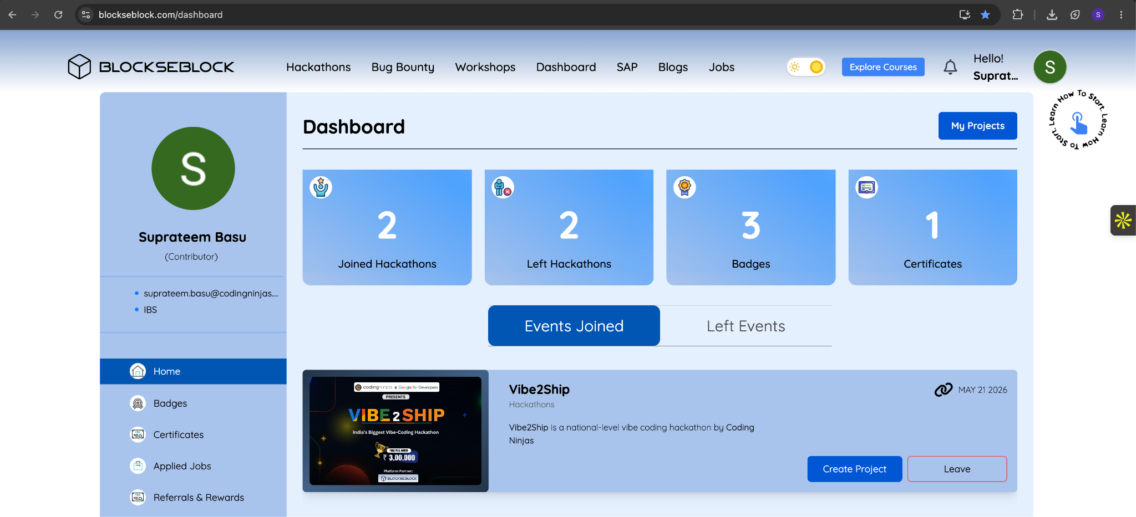
Step 2: Enter your unique Project Name -> Select the Problem Statement you have chosen -> Click on “Save & Next”

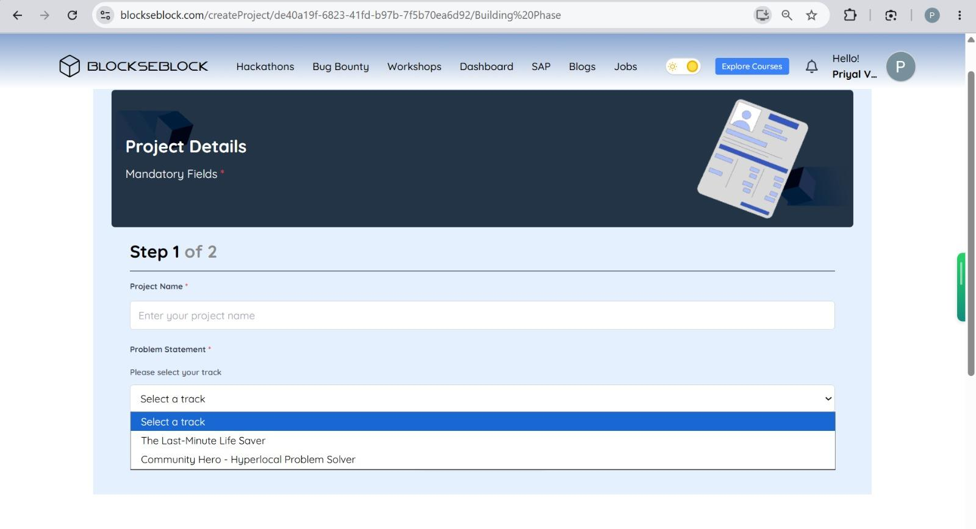

Step 3: Provide the mandatory links as per the submission requirements -> Click on “Submit Now”

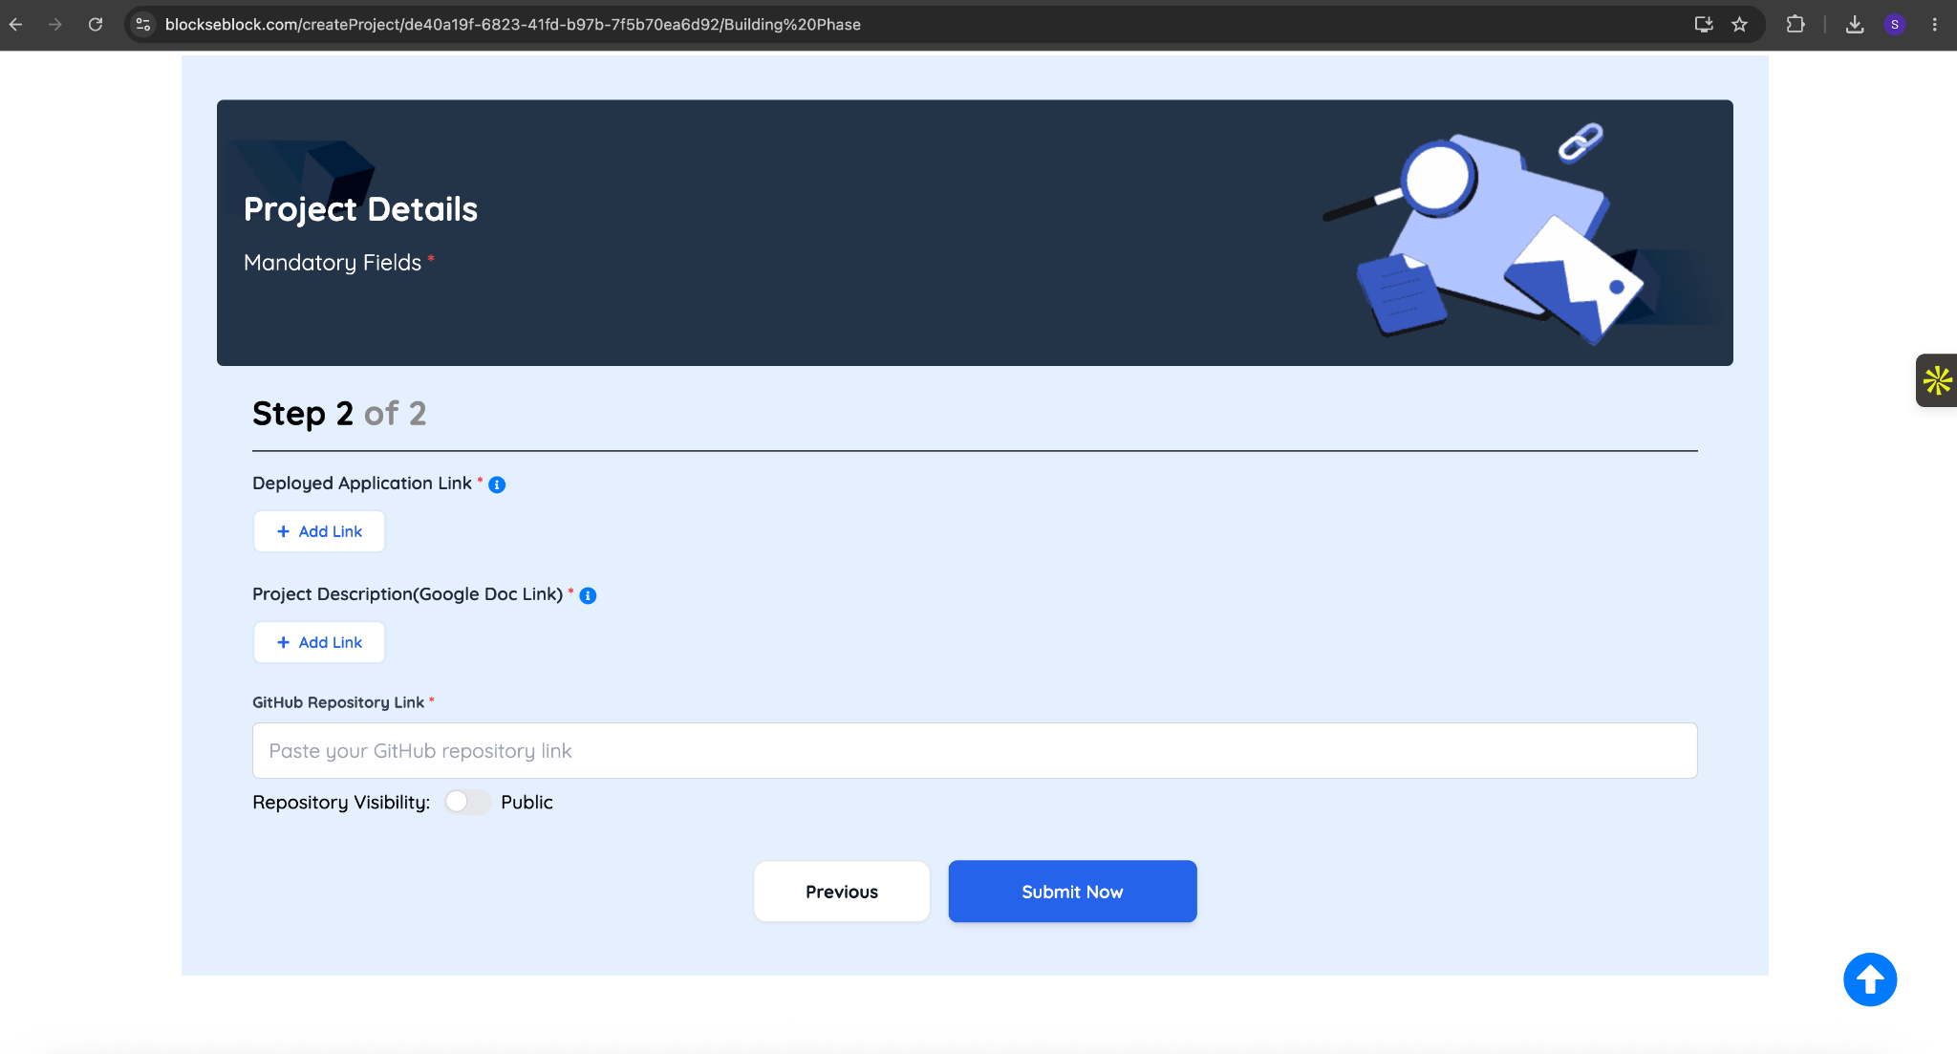

Step 4: Toggle On both Note -> Click on “Continue”

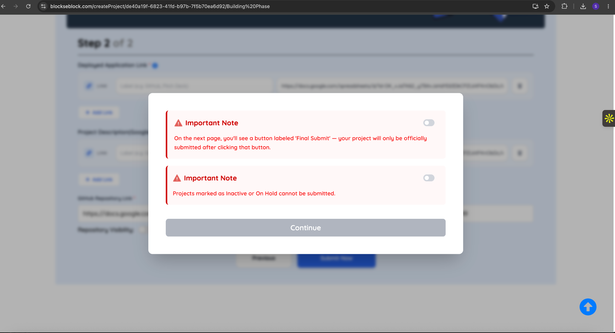

Step 5: Click on “Final Submit” (Note: Please proceed with this step only when you are fully satisfied with your submission. Once completed, you will not be able to modify, edit, or resubmit your entry.)

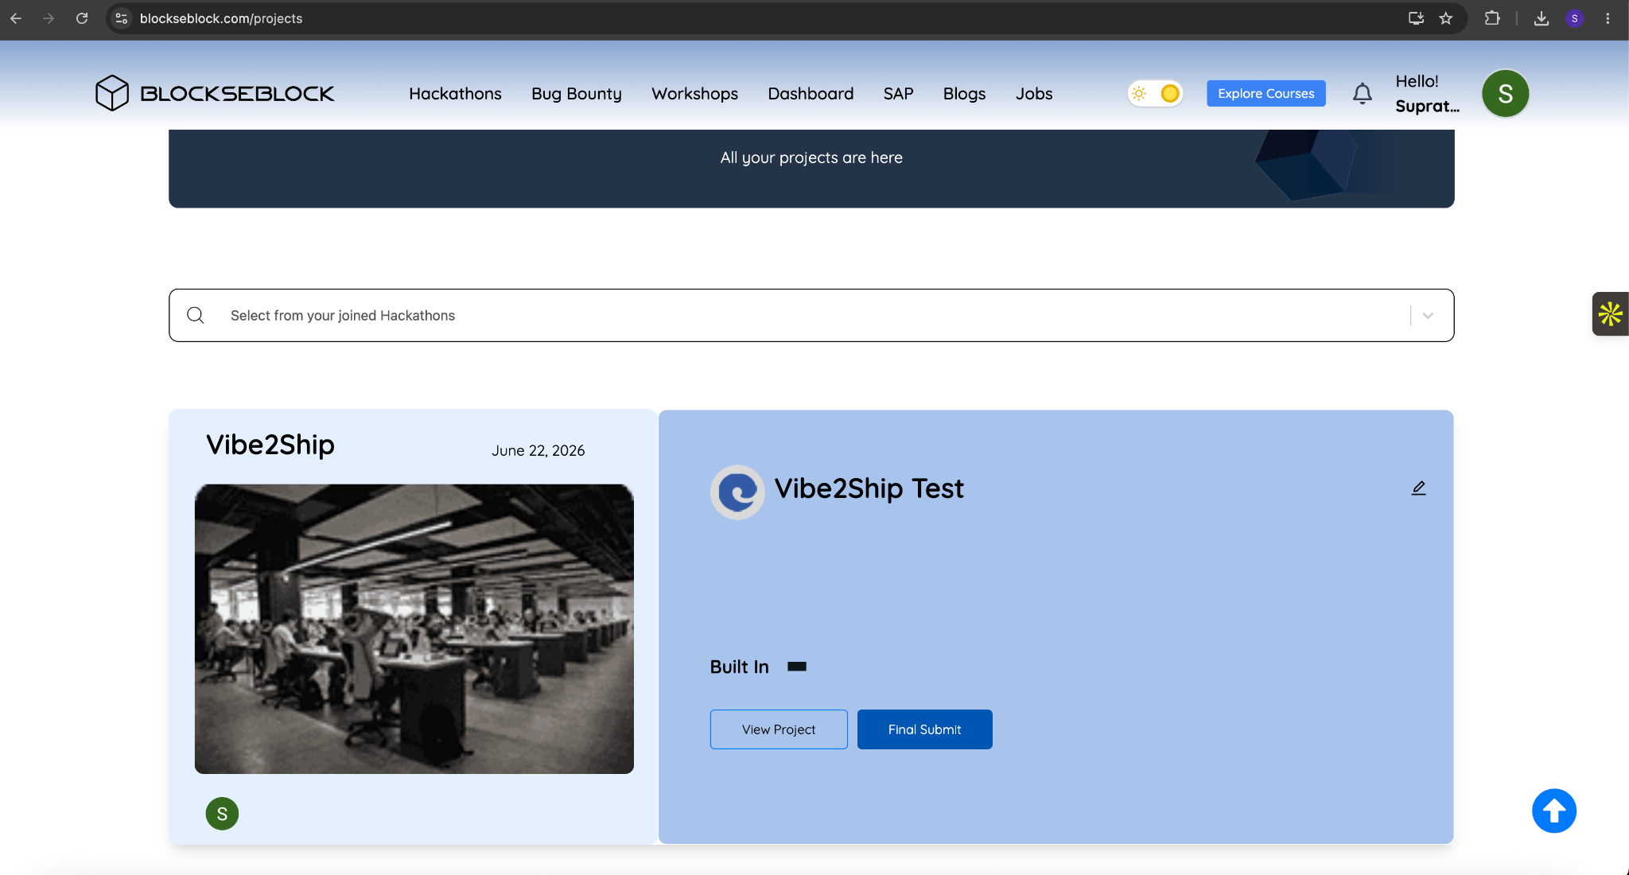
You have now successfully submitted your solution

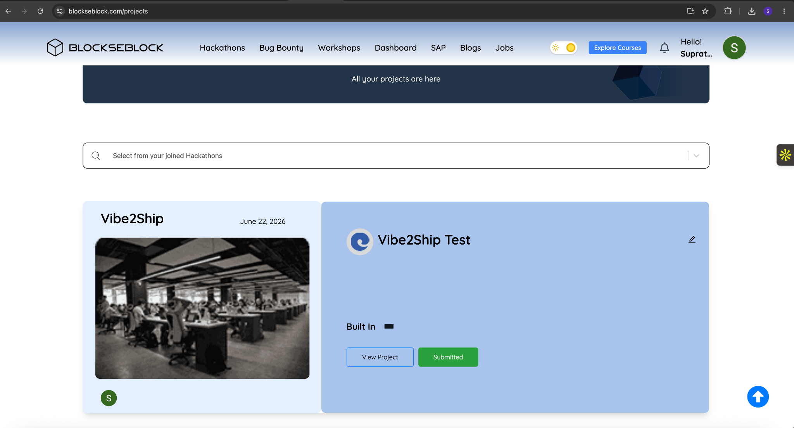
Important- Step 5 is compulsory otherwise your submission will be in drafts. To verify your submission, follow below steps-

Step 1: Go to your Dashboard -> Click on “My Projects”

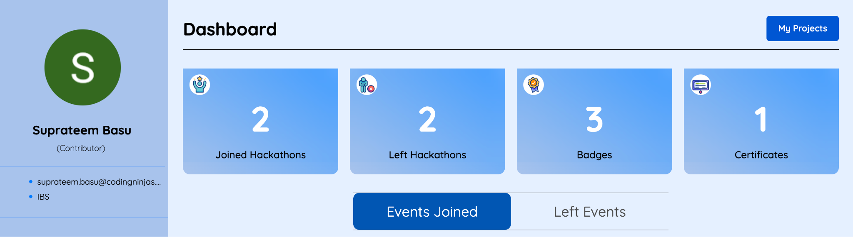

It should show Submitted against your project

